Project Design Phase-II Technology Stack (Architecture & Stack)

|  |  |
| --- | --- |
| Date | 16 October 2022 |
| Team ID | PNT2022TMID11825 |
| Project Name | News Tracker Application |
| Maximum Marks | 4 Marks |

Technical Architecture:

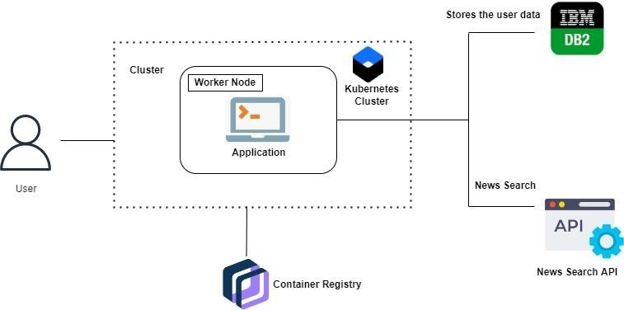

Table 1: Components & Technologies:

|  |  |  |  |
| --- | --- | --- | --- |
| **S.No** | **Component** | **Description** | **Technology** |
| 1. | User Interface | The user can interact with the application toknow about the trending news | HTML,CSS,  JavaScript/  Angular Js/ ReactJs etc. |
| 2. | Application Logic-1 | The application contains this resource gives you basic understanding of Flask | Flask |
| 3. | Application Logic-2 | The application contains the news sub- division like geographical news, economicnews  and society news | IBM Watson STT service |
| 4. | Application Logic-3 | The user can view the growth of the economy in industry through graph | IBM Watson Assistant |
| 5. | Database | Updation of trending news are stored in the MySQL database | MySQL, NoSQL,  etc. |
| 6. | Cloud Database | With the use of cloud, media coverage issue cannot be occurred | IBM DB2, IBM  Cloudant etc. |

Table 2: Application Characteristics:

|  |  |  |  |
| --- | --- | --- | --- |
| **S.No** | **Characteristics** | **Description** | **Technology** |
| 1. | Open-Source Frameworks | Flask is flexible and doesn’t require touse any particular project or code  layout used in this application | Python-Flask |
| 2. | Security Implementations | This can be access only by the journalist. So, It is a high Security | Container Registry, Kubernetes Cluster. |
| 3. | Scalable Architecture | News Tracker is a socio-economic access because helps to know aboutthe daily activity of the world | Container Registry, Kubernetes Cluster. |
| 4. | Availability | This application will be available to the all the user who are using this  application | Container Registry, Kubernetes Cluster. |
| 5. | Performance | The updation of trending news occurs without any interruption. So,it performance is good | Kubernetes Cluster. |

References:

https://ieeexplore.ieee.org/document/5616930

https://ieeexplore.ieee.org/document/1565880

https://ieeexplore.ieee.org/document/8703401